**App: RamsHeadGroup**

**Watch App ScreenShots**

**Before Login in your account:**

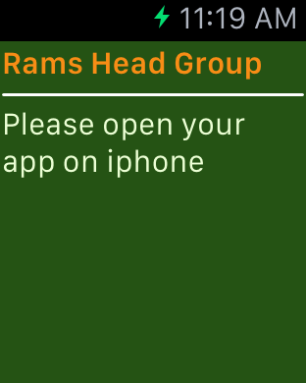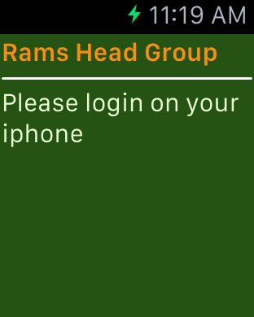

**After login:**

The actions on either your iPhone or your Apple Watch would affect the other.

For example, if your tap the “Points” cell in the iPhone app or “View Points” button in the Watch app, both the iPhone and Watch would show the points at the same time.

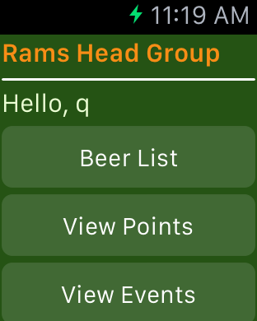

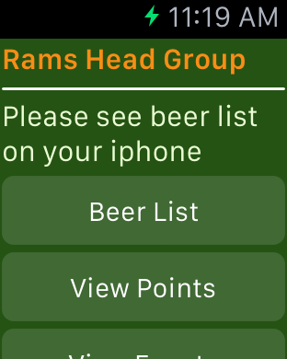

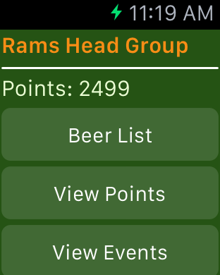



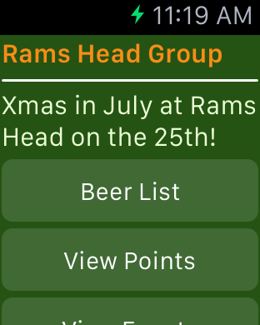

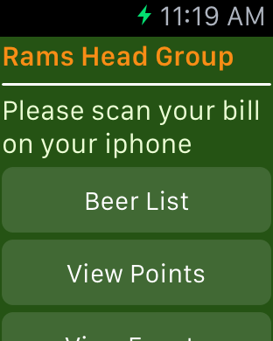

**Notification Scene:**

When you receive a push notification without using your iPhone, the notification will show on your watch.

